Module Assembly - TC Cockpit Platform Specialist Utilization Report and Graph version 1.0
Deployment Guide

Revision History
Author | Revision Number | Date
Blues | 1.0 | March – 4th - 2013

Deployment Instructions 3
1. Organization of Submission 3
2. Application Setup 3
2.1 Ant .Properties File 4
2.2 Build Scripts Setup 4
3. Database Setup 4
3.1 query tool Setup 4
3.2 Test Data Setup 4
4. Deployment Instructions 5
4.1 Deploy Direct 5
5. Starting 5
6. Verification 5
7. Resource Contact List 7

Deployment Instructions

Organization of Submission

The content of submission follows directory structure provided below:

direct

Contains the sources and configuration of the cockpit application in this assembly

docs

Contains this document which is the deployment guide for this assembly.

test_files
This folder contains the test files for this assembly, they will be used to verify the assembly.

db_query
Contains the new and upated queries in this assembly.

db_trunk
This folder contains updated DB scripts for DB trunks. These files are commit-ready.

Application Setup

The application is expected to be deployed to the following environment:

- JRE 1.5
- JBoss 4.2 GA
- Informix DS 11.0
- MySQL 5.x
Configuration file / property name | Comments
direct/conf/web/WEB-INF/applicationContext.xml | Add the spring injection configuration for new action: platformSpecialistsReportAction
direct/conf/web/WEB-INF/struts.xml | Added actions platformSpecialistsReport and getPlatformSpecialistsReportData  Added interceptor tcStaffAccessGuard (com.topcoder.direct.services.view.interceptor.TCStaffAccessInterceptor)  Added stack securedTCStaffStack which uses the interceptor tcStaffAccessGuard

Ant .Properties File
No changes were performed regarding Ant .Properties file.

Build Scripts Setup
The ANT build script for Direct application (build.xml) provides the following targets which are to be used:

- switch-and-checkout – checkout or switch to the defined source code branches for all components defined in subprojects.xml
- dist-backend – rebuilt all the components from the source code.
- first_deploy – must be the first task to execute from command line. It will copy all dependencies to your local JBoss folder.
- deploy – should be the main task to execute from command line. It will build and deploy WAR file.
- deploy-static-files – deploys the static files to JBOSS.
- deploy-apache-static – deploys the static files to apache server on VM.

Please refer here for more information:
http://www.topcoder.com/wiki/display/docs/TC+Direct+Setup+Guide

Database Setup

query tool Setup

- Queries should be added for database tcs_catalog via Query Tool
In directory db_query\ query_get_all_topcoder_platform_specialists.txt

COMMAND: get_all_platform_specialists
- QUERY: get_all_platform_specialists

In directory db_query\ query_member_spent_by_platform_specialist.txt

COMMAND: member_spend_by_platform_specialist
- QUERY: member_spend_by_platform_specialist (inputs: uids, sdt, edt)

Test Data Setup

Insert test data

You need to execute test_files/test_data.sql against the Informix database to insert projects and contests test data.

You need to execute test_files/ insert_tc_staff.sql to give TC staff role to 3 test users

You need to execute test_files/ insert_platform_specialists.sql to add platform specialists to 3 projects

Upload the test_files/projectBillingLoader to the VM
- cd projectBillingLoader
- run ‘ant run’ to load billing accounts mappings

If you run the projectBillingLoader on local environment, please update projectBillingLoader\conf\config.properties, replace ‘env.topcoder.com’ to ‘localhost’

Deployment Instructions

Deploy Direct
- Login as direct
- Merge the direct dir in the submission folder to the /home/direct/direct folder on the VM
- Build and deploy Direct application using ant deploy (or ant first_deploy ) command.
- Copy static files using ant deploy-static-files command or ant deploy-apache-static if use apache as static file server.

Starting
Cockpit backend and Direct need to be started for this assembly.

Verification
Go to http://cockpit.cloud.topcoder.com/direct/ and login as heffan with password ‘password’

In the first page, click the Dashboard dropdown menu at the left upper corner

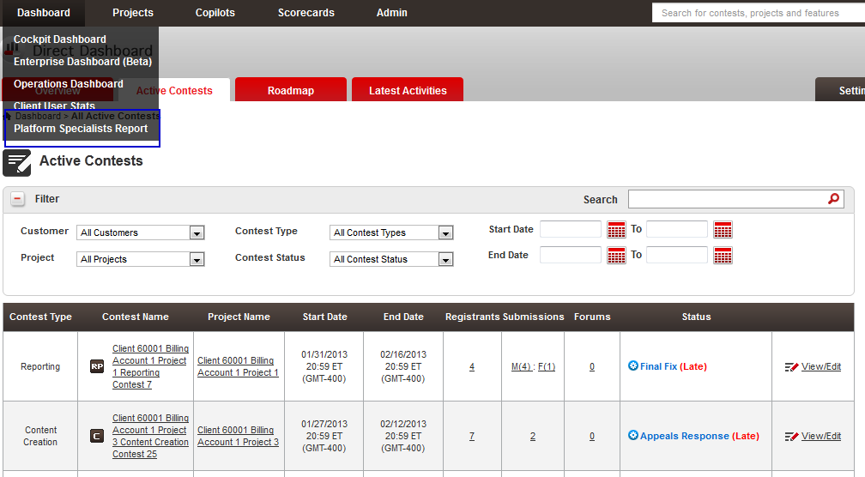

Choose “Platform Specialists Report”

The report for the first platform specialist is displayed

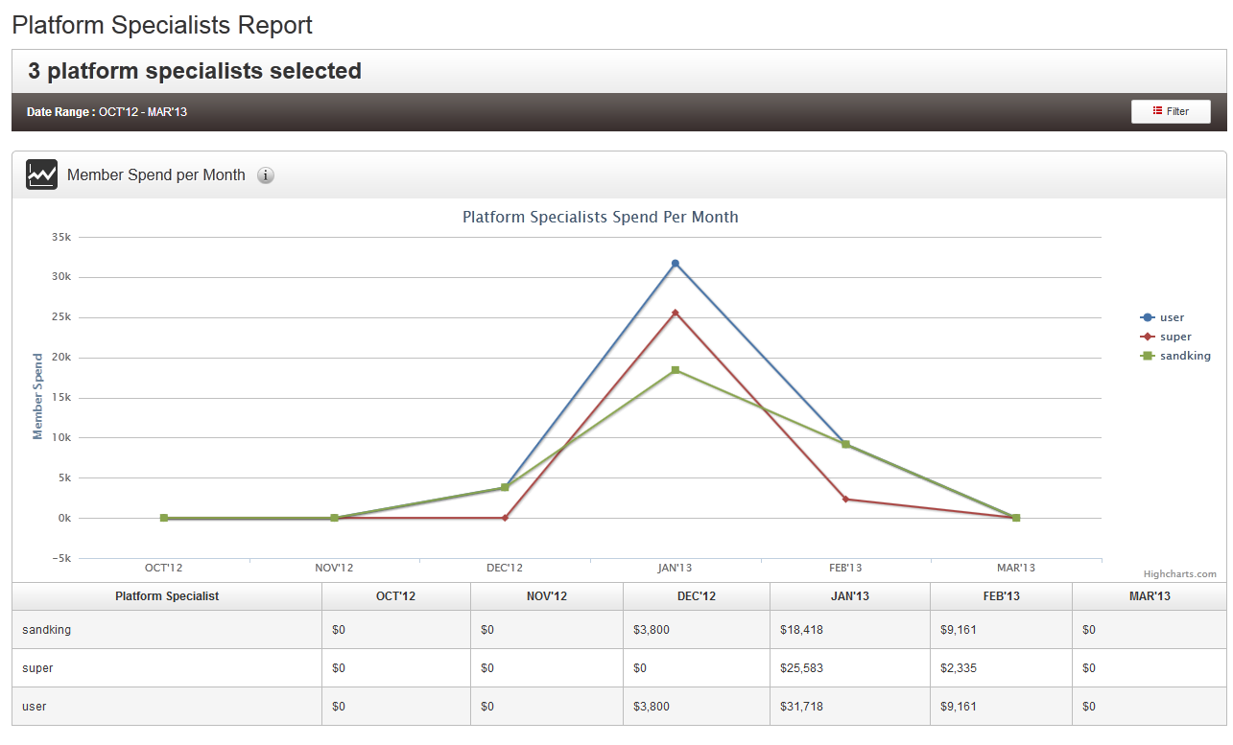
Click the filter button to change platform specialists and time

All the platform specialists with role TC staff are listed

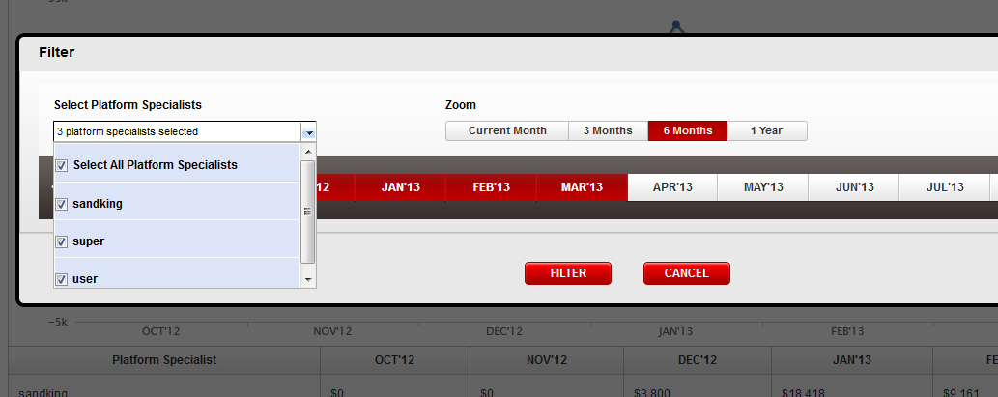

Click Filter again

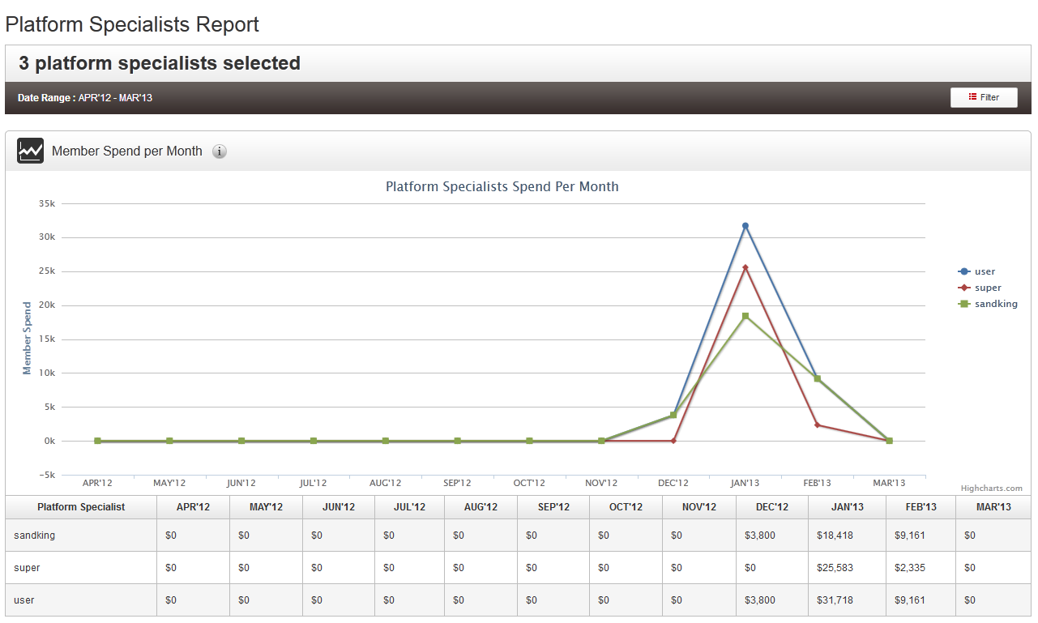

Change to one month

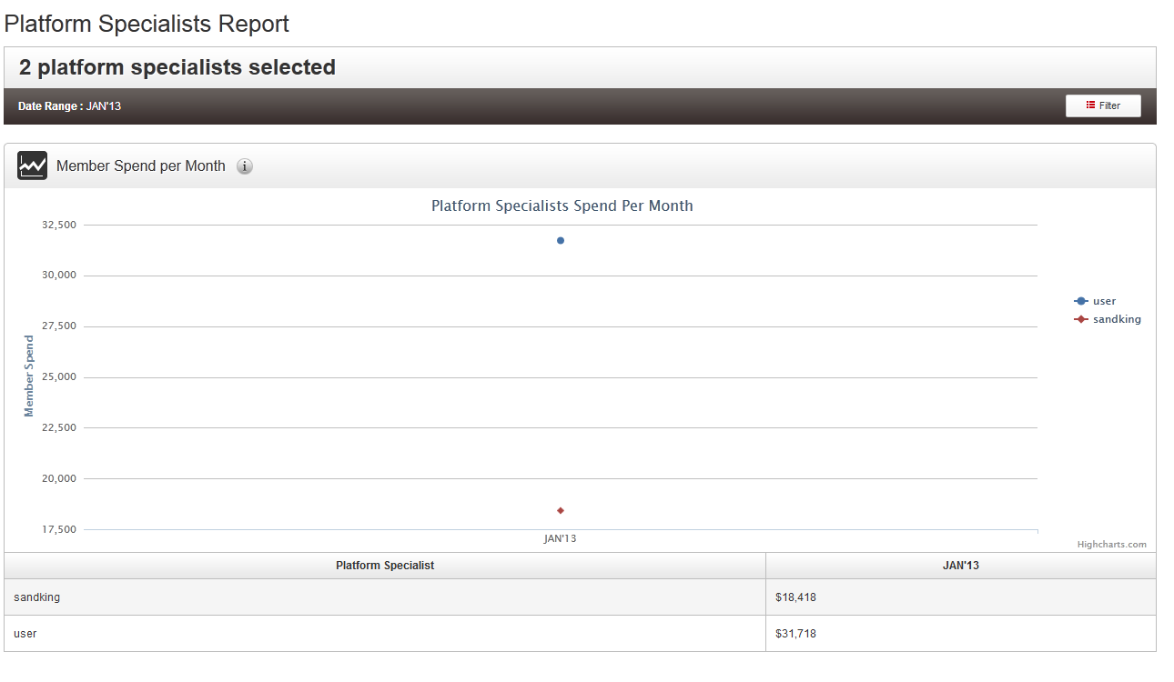

Access the report with an non TC staff account, you can see

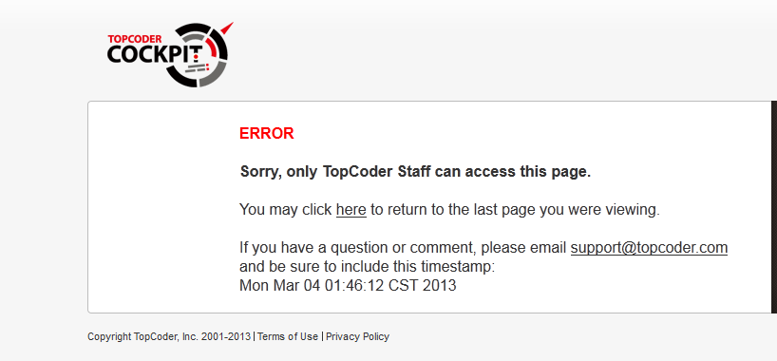

Check platform specialists on these 3 projects

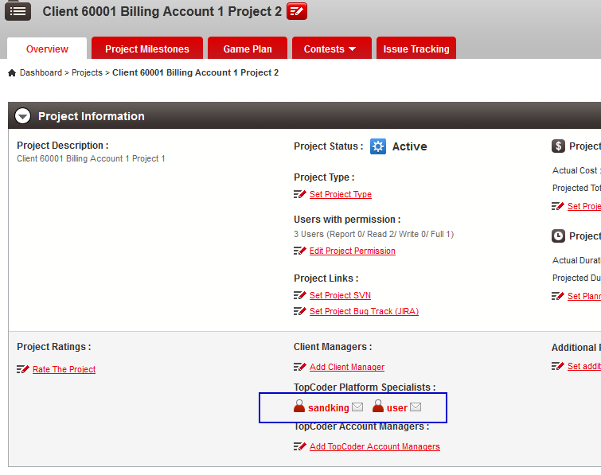

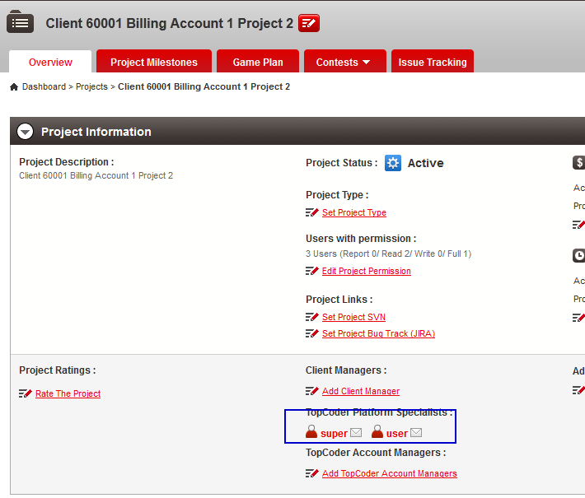

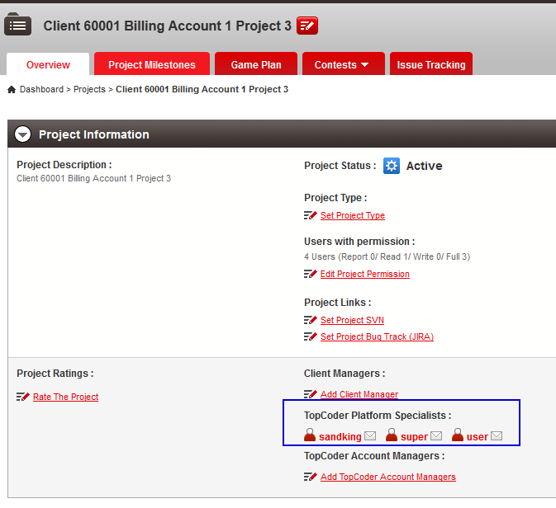

Resource Contact List
Name | Resource Email
TCSASSEMBLER

